Name: | G.K.Abhinaya
RollNo: | 73771921102
Team ID: | PT2022TMID11856

CIRCUIT DIAGRAM

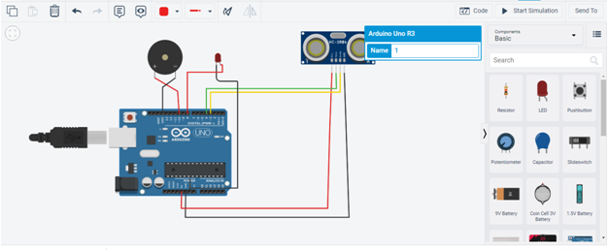

Code:

int trigpin=4;

int echopin=3;

int buzzerpin=10;

int time;

int distance;

void setup()

{

pinMode(8,OUTPUT); pinMode(3,INPUT); pinMode(4,OUTPUT); pinMode(10,OUTPUT); Serial.begin(9600);
}
void loop()

{

digitalWrite(trigpin, HIGH); delayMicroseconds(1000); digitalWrite(trigpin, LOW); delayMicroseconds(1000); time=pulseIn(echopin,HIGH); distance=(time*0.034)/2; if(distance<=10)
{

Serial.print("Distance= "); Serial.println(distance); digitalWrite(8,HIGH); delay(1000); digitalWrite(10,LOW); delay(1000);
}

else

{

Serial.print("Distance= "); Serial.println(distance); digitalWrite(8,LOW); delay(1000); digitalWrite(10,HIGH); delay(1000);
}

}
OUTPUT

